

**Project Charter**

Charity Second-hand Online Store

**Revised records**

|  |  |  |  |
| --- | --- | --- | --- |
| **Update Date** | **Version** | **Description** | **Name** |
| 2020-03-23 | V1.0 | Initial | Cong Shang |
|  |  |  |  |
|  |  |  |  |
|  |  |  |  |

Table of Contents

1 Summary 4

1.1 System Objectives 4

1.2 Overview of the project charter 4

2 Project schedule 5

2.1 Milestone list. 6

3 Stakeholders 6

3.1 Responsibility of stakeholders. 6

3.2 Stakeholders Contact 7

4 Communication plan 8

4.1 Meeting type 8

4.1.1 Team meeting 8

4.1.2 Advisor meeting 8

4.1.3 Team meeting 8

4.2 Meeting process 8

4.3 Communication methods 8

5 Project training plan 9

6 Risk Management 9

6.1 Risks identification 10

6.2 Risks analysis 10

6.2.1 Probability of risk events 10

6.2.2 The impact of risk events 11

6.3 Risk Response approach 11

6.4 Risk monitoring 12

7 Project change management 12

7.1 Change Control Board 12

7.2 Change control process 12

8 Project document management 12

8.1 Project name 12

8.2 Document directory structure 12

8.3 Document version management 14

# Summary

## System Objectives

The objective of this project is to set up an online auction store for the second-hand store. This system will provide a convenient online shopping experience for the customers and raise more money for the store.

## Overview of the project charter

In order to enable the project team to complete the project objectives on time and satisfying quality. This document will descript the specifies the project schedule, team responsibilities, communication plan, change control management, document naming specification and so on.

# Project schedule

The project starts from 10 March 2020 to 29 May 2020. The main tasks of the project are shown in the picture below. The detailed project schedule, please the document” COS-20200518.mpp”

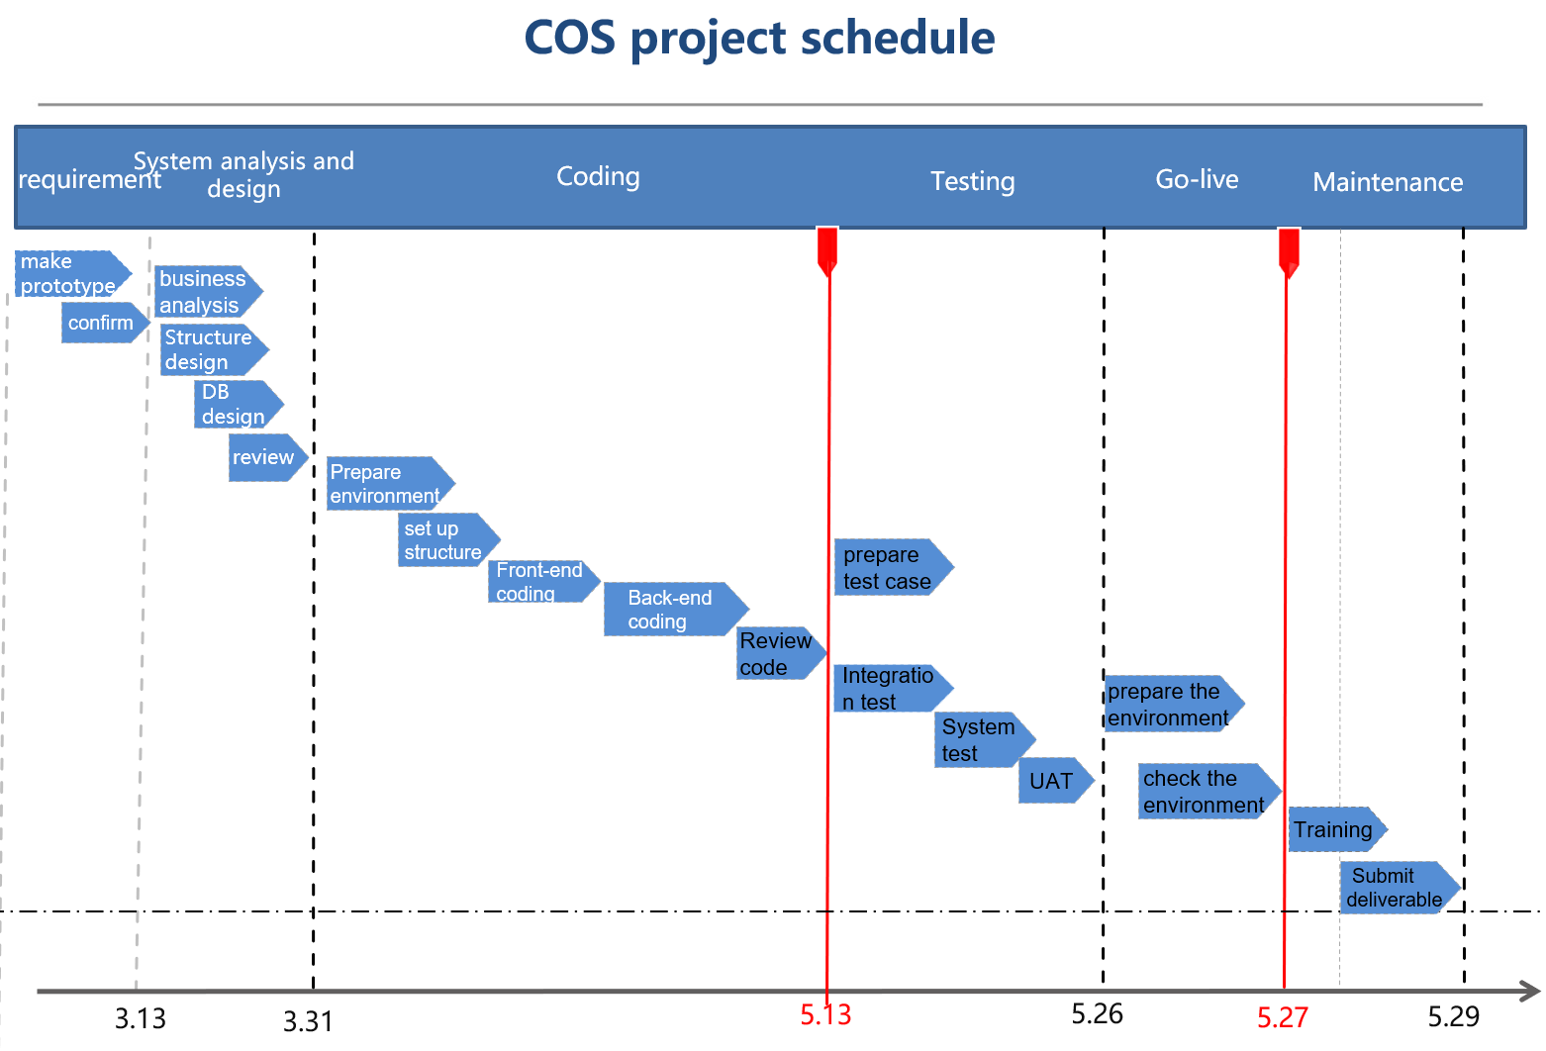

In the process of the project progress, we need to check the state of the schedule frequently to ensure progress does not deviate greatly from the plan. so the following planning management work should be carried out:

1. Each task must have a clear work plan and a person in charge

2. compare the progress of the project with the plan every week, if a large deviation is found, it should be recorded at the tutor meeting.

3. the progress deviates, the risk analysis should be carried out in time, and the workload should be evaluated.

## **Milestone list.**

|  |  |  |  |  |
| --- | --- | --- | --- | --- |
|  | Milestone list. | |  |  |
|  |  |  |  |  |
| No. | Milestones | Date | Events | Deliverable |
| 1 | Initiation | 23/03/2020 | Advisors and clients accept project team proposal | project proposal |
| 2 | Design | 30/03/2020 | Complete project design review, including page design, database design process design, system structure design. | System Analysis and Design document |
| 3 | Development | 13/05/2020 | Complete code writing and unit testing. Code quality reviewed | Project source code |
| 4 | Testing | 26/05/2020 | Complete integration test, system test, and acceptance test. Client satisfies the user acceptance test. | testing plan, test cases and test reports |
| 5 | Go-live | 29/05/2020 | support the project go-live | Submit the user manuals, installation manuals and training material |
| 6 | Closing | 08/06/2020 | Deliver all deliverables and summarize project lessons. | All documents related to the project, mainly closing reports |

# Stakeholders

## **Responsibility of stakeholders.**

Role and responsibility of stakeholders.

|  |  |  |
| --- | --- | --- |
| Name | **Role** | **Responsibility** |
| Zoe Liu | Client | Propose project requirements, responsible for project acceptance testing and receiving project deliverables |
| Robert Sutcliffe | Super Advisor | The boss of this project. Responsible for evaluating and directing project implementation |
| Ian Hunter | Project Advisor | Provide guidance on project implementation and suggestions for improvement. |
| Guozhi Yin | Project Manager | Collect customer requirements, responsible for the design, testing, project communication, Scope management， |
| Cong Shang | Software Developer | Responsible for project development, schedule management. Etc. |

## **Stakeholders Contact**

|  |  |  |
| --- | --- | --- |
| Name | Contact information | |
| Email | Mobile |
| Zoe Liu | [zoeqs520@gmail.com](mailto:zoeqs520@gmail.com) | 273608021 |
| Robert Sutcliffe | [Robert.Sutcliffe@weltec.ac.nz](mailto:Robert.Sutcliffe@weltec.ac.nz) |  |
| Ian Hunter | [Ian.hunter@weltec.ac.nz](mailto:Ian.hunter@weltec.ac.nz) | 649202696 |
| Guozhi Yin | [30845878@qq.com](mailto:30845878@qq.com) | 211882339 |
| Cong Shang | [shangcongvip@163.com](mailto:shangcongvip@163.com) | 211350560 |

# Communication plan

## Meeting type

|  |  |  |  |
| --- | --- | --- | --- |
| No. | Description | Frequency | Method |
| 1 | Team meeting | Weekly | WeChat |
| 2 | Advisor meeting | Weekly | Zoom |
| 3 | Client meeting | Weekly | WeChat |

### Team meeting

Meeting time: Saturday 10 AM -12 AM

Content: Discuss weekly work and track project progress.

Participants: all team numbers;

Communication method: Using WeChat to communicate

### Advisor meeting

Meeting time: Monday 11 AM -12 AM

Content: Report the project progress and review the project document.

Participants: Advisor and team number;

Communication method: ZOOM. 935-4876-5560

### Team meeting

Meeting time: Tuesday 11 AM -12 AM

Content: show project progress and report project work.

Participants: all team numbers and client;

Communication method: Using WeChat to communicate

## Meeting process

1. The day before the meeting with customers and tutors, the meeting organizer will prepare the meeting agenda and share to the relevant meeting members.
2. During the meeting, the remaining issues of the previous meeting will be discussed firstly, and track the progress of the decisions of the previous meeting.
3. After the meeting, prepare the minutes. Send to relevant members and follow up the decision.

## Communication methods

1. WeChat or telephone communication is used within the project.
2. WeChat can be used to discuss requirements with customers, but email should be used for document delivery
3. Use email to communicate with our advisor and telephone to communicate in case of emergency

# Project training plan

The project team will be held two times of face-to-face training for the client including training client how to do user acceptance tests and how to write test reports. The main content of the second training is how to use the system and answer questions.

|  |  |  |  |  |  |  |
| --- | --- | --- | --- | --- | --- | --- |
| No. | Training Type | Train method | Training content | Date | Participants | Instructor |
| 1 | Test training | face to face | Testing methods for user acceptance tests and how to write test reports | 25/05/2020 | Client | Guozhi Yin |
| 2 | Operational function training | face to face | Training users on how to use the system | 27/05/2020 | Client | Guozhi Yin |

# Risk Management

The project is planned and implemented in order to achieve the project objective. Although the project should be implemented according to the project plan in the process of project implementation, the results of all plans are often not guaranteed, because there may be many unexpected factors. In the process of project implementation, it is necessary to monitor the implementation of the project at any time, identify the possible risks, carry out a qualitative and quantitative analysis of the project risks. Meanwhile, the project team also should formulate effective risk response plans to minimize the losses caused by the project risks

## Risks identification

The event of the risk identification is to find the uncertainty factors affecting the project into a clear risk statement. Any stakeholder can resist the potential risks in the project risk register.

The risks in the project include the following aspects (but not limit the following):

1. Communication risk
2. Human resource risk
3. Technical risk
4. Schedule risk
5. Scope risk
6. Quality risk

## Risks analysis

The process of risk analysis is to analyze the risk statement and get the priority of risk. So, they provide some basic information for the next step of risk response.

In order to identify the most important risk events, two factors that determine the importance of risk events need to be analyzed:

1. the probability of risk occurrence (and its frequency, if possible, happened more than one times)
2. Impact of risks on the project.

The importance of risk events is directly proportional to these two factors, that is, the higher the probability of occurrence, the more important the risk; the greater the impact, the more important the risk. According to the importance of risk events, we should pay attention to different levels and formulate different risk reduction strategies. Generally, the risk with large impact but low possibility needs more attention than the risk with small impact but a high possibility.

### Probability of risk events

Base on the probability of occurrence of risks, we divide the probability of risk into five grades as the following shows.

| Grades | Explanation | Probability |
| --- | --- | --- |
| Very high risk | Obviously, the probability of happening is significantly higher than that of not happening | 80 % - 99 % |
| Hight risk | More likely to happen | 60 % - 79 % |
| Moderate risk | The occurrence and non-occurrence have a similar probability | 40 %– 59 % |
| Low risk | Not likely to happen | 20 % - 39 % |
| Very low risk | Probably not happen | 0 % - 19 % |

### The impact of risk events

| Grades | Explanation | Impact on project time |
| --- | --- | --- |
| Severe | Causing a critical part of the project to fail that of not happening | Delay of one month |
| High | Which leads to the failure of the more important part of the project | Delay of 14 days |
| Medium | will affect the implementation effect of some parts of the project | Delay of 7 days |
| Low | Will weaken the functionality available to the client | Delay of 3 days |
| Negligible | Has little impact on the functionality available to the client | Delay of 1 day |

## Risk Response approach

The usual approach is to first deal with any risk event with high impact/likelihood, second with risk event with medium impact/likelihood, and then consider risk event with high impact/probability.

Risk management methods include：

1. Risk aversion: the usual way is to find out the cause of the risk and prevent it from happening
2. Risk mitigation: reduce the possibility or impact of risk
3. Risk acceptance: the occurrence of risk acceptance
4. Risk transfer: seek help from our advisor.

## Risk monitoring

The risk monitoring process includes monitoring the status of risk events in order to issue a notice to initiate risk response actions when risk events occur

1. Inform relevant personnel of current major risk events and their status.
2. Timely inform the risk events that will turn into problems and arrange relevant persons in charge to deal with them

# Project change management

In order to prevent project out of control and standardize project management, the "project requirements change management process" is used to manage the changes to the confirmed requirements during project implementation.

## Change Control Board

The change control board of this project include advisor and client.

## Change control process

1. Propose change request.
2. Analyze the content and impact of the change
3. Change Control Board decides whether to accept the change.
4. Implement the change.
5. Record the change process and update the documents.
6. Verification of changes

# Project document management

## Project name

Project name: Charity Online Store

Short name：COS

## Document directory structure

| Frist | Second | Third | Description |
| --- | --- | --- | --- |
| * Project |  |  |  |
|  | * 01_PM |  |  |
|  |  | 0 Integration management | Including project charter, project mandate document, etc |
|  |  | 1 Requirement management | Method of managing requirements, tracking of requirements management |
|  |  | 2 Schedule management |  |
|  |  | 3 Cost management |  |
|  |  | 4 Scope management | WBS, Scope statement |
|  |  | 5 Risk management | Risk management plan, strategy and register risk information |
|  |  | 6 Stakeholders management |  |
|  |  | 7 Human resource management |  |
|  |  | 8 Communication management | Meeting agenda and meeting reports. |
|  | * 02_Requirment |  |  |
|  |  | 21_User requirement |  |
|  |  | 22_System requirement | Requirement analysist includes system problems and solutions. |
|  |  | 23_System template | The template of webpages |
|  |  | 24_Requirment change | Record requirements change information |
|  | * 03_Design |  |  |
|  |  | 31_System Design |  |
|  |  | 32_Database Design |  |
|  |  | 33_Review record |  |
|  |  | 34_Design documents |  |
|  | * 04_Development |  |  |
|  |  | 41_Source code |  |
|  |  | 42_Unit testing |  |
|  |  | 43_Review records |  |
|  |  | 44_Technical documents |  |
|  |  | 45_Issue tracking |  |
|  | * 05_Testing |  |  |
|  |  | 51_Integration testing | Test plan and testing cases, testing report |
|  |  | 52_System testing |  |
|  |  | 53_Non-functional testing |  |
|  |  | 54_UAT |  |
|  | * 06_Maintenance |  |  |
|  |  | 61_Installation Manual |  |
|  |  | 62_Maintenance Manual |  |
|  |  | 63_User manual |  |
|  | * 07_Training |  | Training materials |
|  | * 08 Closing |  | lesson-learned.  Summary experience |

## Document version management

The project team uses google drive to management the version of project documents.